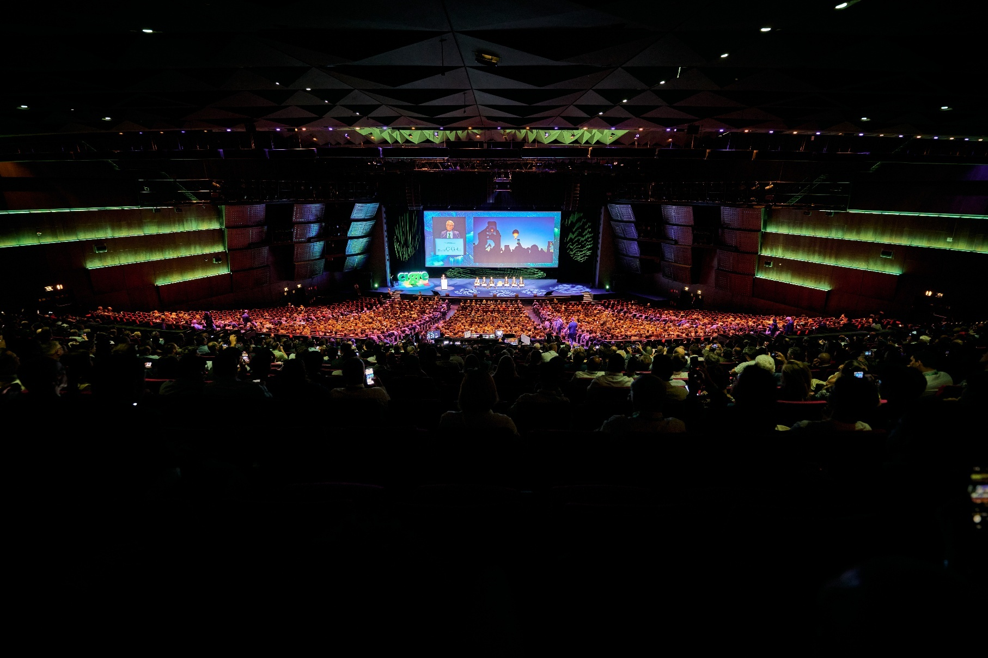

|  |
| --- |
|  |
| SYNOPSES FORMAT  Please read carefully  These instructions and the attached template give you guidelines to prepare your synopsis.  Please strictly follow these instructions and provide us with the necessary information we need to consider your Paper Proposal.  Study Committee and Preferential Subject addressed are mandatory to direct your synopsis to the right experts for reviewing.  Your email address is highly needed to keep you informed about the selection results.  Synopses format is standardised and must be A4 size, one column and line spacing 1.15. Font should be Times New Roman.  Synopses should be in English and unpublished material with strictly scientific or technical contents.  No advertising or commercial names are allowed in the text.  A length of 500 words minimum and two pages is a good option to facilitate reviewing and selection.  A few keywords in alphabetical order, separated by commas may serve as an introduction.  The timeline for the whole Papers process can be found in the Call for Papers. See regularly our Session [website](https://session.cigre.org/) for possible updates.  Thank you for your attention!  Format must be A4 size with Margin: Left 2.5 cm, Right 2.5 cm, Bottom 2.5 cm. Study Committee, Preferential Subject and synopsis title must be with: Font Name Helvetica or Arial Bold size 12. Authorship must be with Times New Roman bold size 12 and center-aligned. Authors’ family name should be in Upper Case.  Text must be in one Column after Authors Name, Font Times New Roman size 12 and Line Spacing 1.15. A Length of 500 words minimum to two pages maximum is a good option to facilitate reviewing and selection.  About four Keywords in alphabetical order, separated by commas may serve as an introduction.  Tables or figures should be limited in number.  Thank you for your attention!  SYNOPSES TEMPLATE  Please read carefully. These instructions and the attached template give you guidelines to prepare your synopsis.  Please follow strictly these instructions and provide us with the necessary information we need to consider your Paper Proposal.  Study Committee and Preferential Subject addressed are essential to direct your synopsis to the right person for reviewing.  Your email address is highly needed to keep you informed about the selection results.  Format must be A4 size with Margin: Left 2.5 cm, Right 2.5 cm, Bottom 2.5 cm. Study Committee, Preferential Subject and synopsis title must be with: Font Name Helvetica or Arial Bold size 12. Authorship must be with Times New Roman bold size 12 and center-aligned. Authors’ family name should be in Upper Case.  Text must be in one Column after Authors Name, Font Times New Roman size 12 and Line Spacing 1.15. A Length of 500 words minimum to two pages maximum is a good option to facilitate reviewing and selection.  About four Keywords in alphabetical order, separated by commas may serve as an introduction.  Tables or figures should be limited in number.  Thank you for your attention!  These instructions and the attached template give you guidelines to prepare your synopsis.  Please follow strictly these instructions and provide us with the necessary information we need to consider your Paper Proposal.  Study Committee and Preferential Subject addressed are essential to direct your synopsis to the right person for reviewing.  Your email address is highly needed to keep you informed about the selection results.  Format must be A4 size with Margin: Left 2.5 cm, Right 2.5 cm, Bottom 2.5 cm. Study Committee, Preferential Subject and synopsis title must be with: Font Name Helvetica or Arial Bold size 12. Authorship must be with Times New Roman bold size 12 and center-aligned. Authors’ family name should be in Upper Case.  Text must be in one Column after Authors Name, Font Times New Roman size 12 and Line Spacing 1.15. A Length of 500 words minimum to two pages maximum is a good option to facilitate reviewing and selection.  About four Keywords in alphabetical order, separated by commas may serve as an introduction.  Tables or figures should be limited in number.  Thank you for your attention!  2026 PARIS SESSION |
|  |



Palais des Congrès, Paris, France

AUGUST 23-28